Name ____________________
This activity involves examining the relation between the graph of a function and the graph of its reciprocal. As you sketch your graphs, look for patterns we might generalize.
- Consider and , that is .
Complete a table of values (decimals)

x |  | 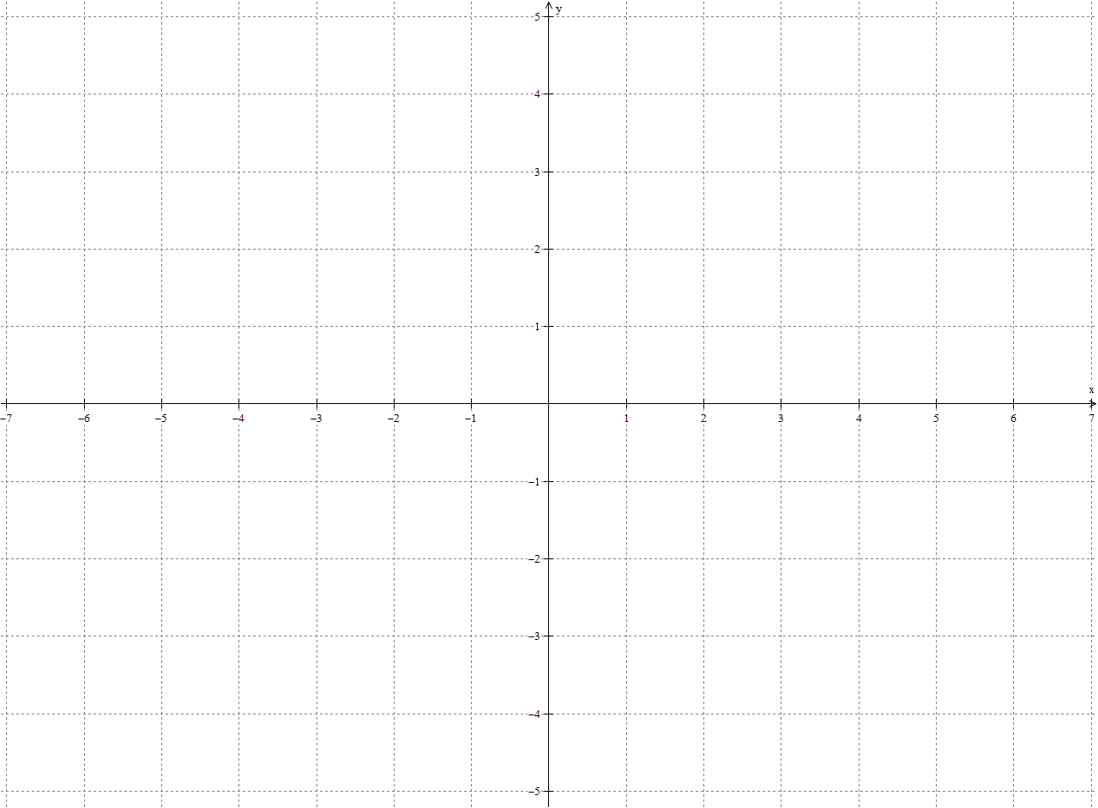
0
.2
.4
.6
.8
1.0
1.2
1.4
1.6
1.8
2.0
2.4
2.8
3.2
3.6
4.0

- Graph each function using a different color for each. Graph ‘simultaneously’, that is, plot 1st f at a given x and then g for the same x before you go onto the next line of the table.

- Observe how one graphed changed as the other changed. Write at least two observations. Discuss these in your group.

- Use your observations to draw the reciprocal of the graph below. If you find this difficult, you might try taking some reciprocals of y values of some points on the given graph and plot like you did above.
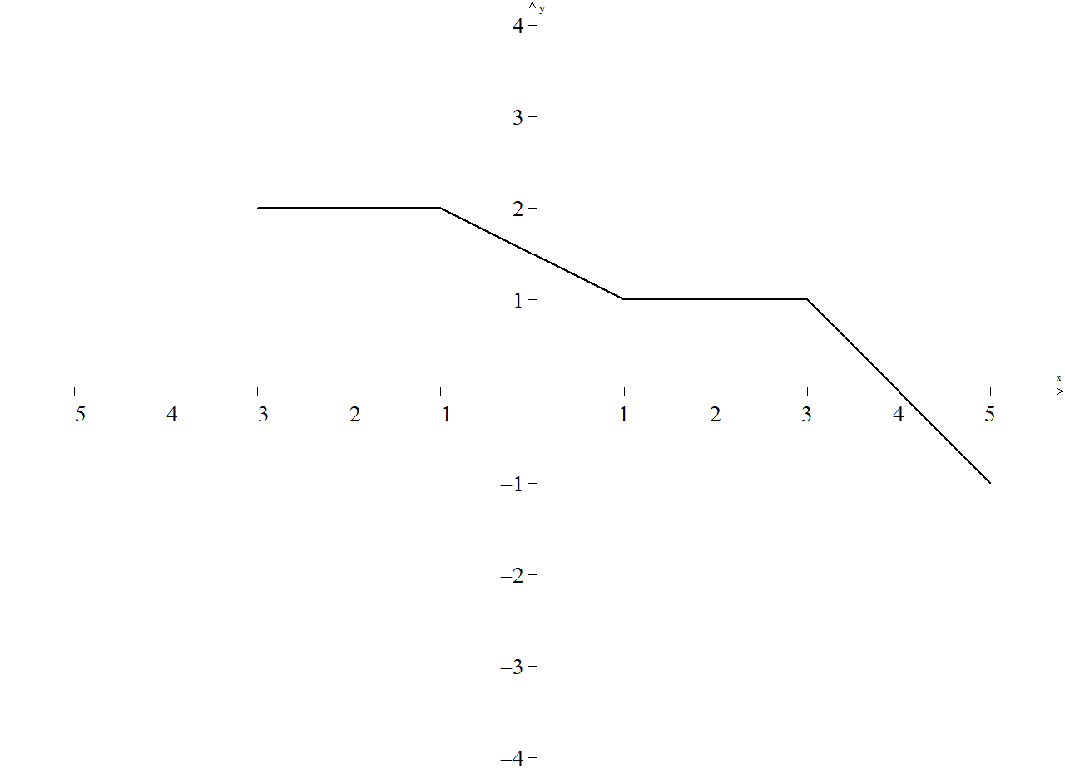

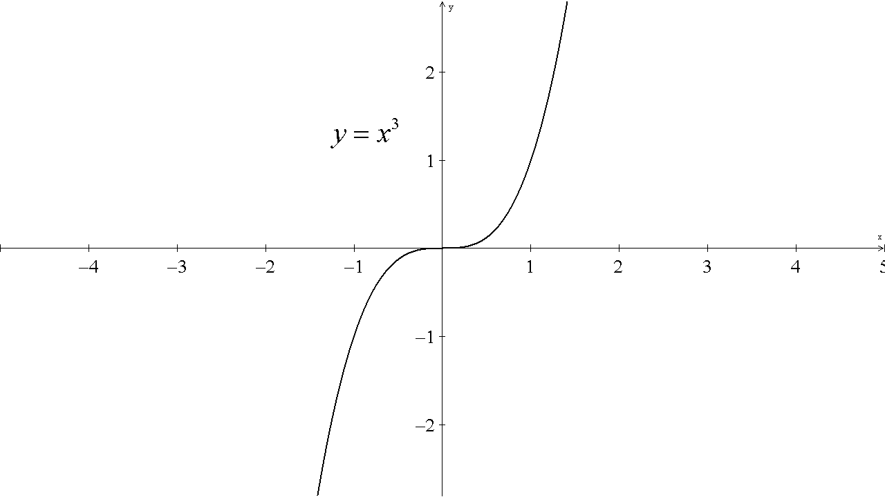

- Based on these problems, write some guidelines for sketching reciprocals. Discuss these in your group.

